EX:04- Create a simple cloud software application for Car Booking ReservationSystem using any Cloud Service Provider to demonstrate SaaS.
Aim
To Create a simple cloud software application for Car Booking ReservationSystem using any Cloud Service Provider to demonstrate SaaS.
Procedure
- Login to Cloud Platform – Sign in to a cloud service provider like Zoho Creator / AWS / Google Cloud.
- Create New Application – Start a new app project, either from a blank template or using a ready-made one.
- Design Forms & Modules – Add forms for customer details, car details, booking requests, and payment info. Create reports to show available cars, booking history, etc.
- Set Workflows & Logic – Automate tasks like booking confirmation, availability check, email/SMS alerts, and payment validation.
- Deploy the Application – Publish the app on the cloud so it works online.
- Provide SaaS Access – Share the application link with users so they can book cars anytime, anywhere through the cloud as a SaaS service.
Output
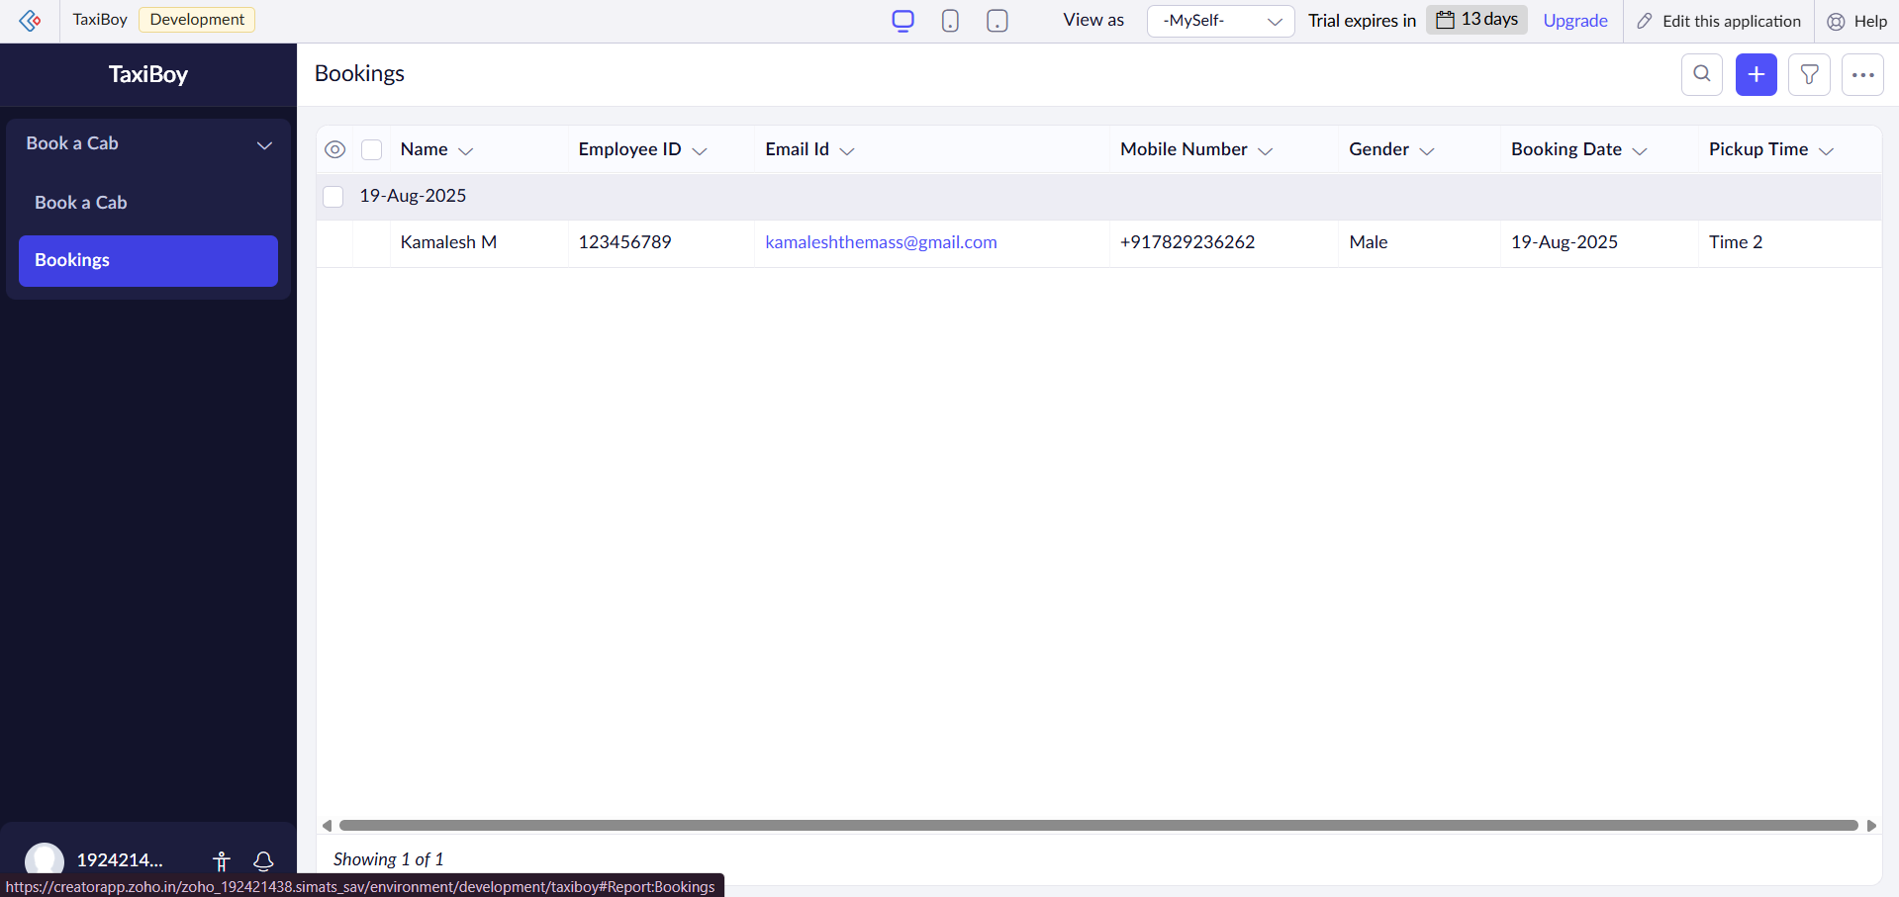
Result
Thus, a simple cloud software application for Car Booking ReservationSystem using any Cloud Service Provider to demonstrate SaaS created successfully.

